**CS205 C/ C++ Programming - Lab Assignment**

**Name**: 何宜芮(Yirui He)

**SID**: 11811031

**Part 1 - Analysis**

Assignment 2 ask we to write a program to deal with several command: start, stop, restart, status, exit. When a command other than "exit" is recognized, the program will display "command <name here> recognized". It must also say "Invalid command" if the command isn't recognized. When "exit" recognized, the program should exit.

Also, commands like "start xxx" are invalid command. Commands like "  start  " is valid. And if user press enter without input anything, a new command prompt will be displayed to indicate user to enter a new command.

We only have:

**char *commands[] = {"start", "stop", ... };**

**#define START_CMD 0**

**#define STOP_CMD 1**

and use in the switch:

**case START_CMD: ...**

First, I need to get the input correctly. Then I use two functions to put them into the right form. I use a variable called "instruction" to check which instruction matches the input. Because we use "#define" to make a connection between commands and integers in advance, we are able to use switch to choose which sentence we are going to print.

**Part 2 – Code**

#include **<iostream>**#include **<cstring>**#include **<cstdio>**#include **<cstdlib>**#include **<cctype>**#define **START_CMD** 0  
#define **STOP_CMD** 1  
#define **RESTART_CMD** 2  
#define **STATUS_CMD** 3  
#define **EXIT_CMD** 4  
#define **BLANK** 5  
#define **ERROR** -1  
  
**void** trim(**char** *, **char** *);  
  
**char** *strlower(**char** *);  
  
**char** *inputString(FILE *, size_t);  
  
**using namespace** std;  
  
**char** *command[] = {**"start"**, **"stop"**, **"restart"**, **"status"**, **"exit"**};  
  
**int** main() {  
 **char** *input;  
 **char** ch;  
 **bool** valid;  
 cout << **"> "**;  
 **while** (**true**) {  
 input = inputString(**stdin**, 100);  
 trim(input, input);  
 input = strlower(input);  
 **int** instruction = -1;  
 **for** (**int** i = 0; i < 5; i++) {  
 **if** (strcmp(input, command[i]) == 0)instruction = i;  
 }  
 **if** (strcmp(input, **"\0"**) == 0)instruction = 5;  
 **switch** (instruction) {  
 **case START_CMD**:  
 cout << **"command start recognized\n"**;  
 **break**;  
 **case STOP_CMD**:  
 cout << **"command stop recognized\n"**;  
 **break**;  
 **case RESTART_CMD**:  
 cout << **"command restart recognized\n"**;  
 **break**;  
 **case STATUS_CMD**:  
 cout << **"command status recognized\n"**;  
 **break**;  
 **case EXIT_CMD**:  
 free(input);  
 input = **NULL**;  
 **return** 0;  
 **case BLANK**:  
 **break**;  
 **case ERROR**:  
 cout << **"Invalid command\n"**;  
 }  
 cout << **"> "**;  
 }  
}  
  
**void** trim(**char** *in, **char** *out) {  
 **int** i, j;  
 i = 0;  
 j = strlen(in) - 1;  
 **while** (isspace(in[i]) && i <= j)  
 ++i;  
  
 **while** (isspace(in[j]) && i <= j)  
 --j;  
 strncpy(out, in + i, j - i + 1);  
 out[j - i + 1] = **'\0'**;  
}  
  
**char** *strlower(**char** *str) {  
 **char** *orign = str;  
 **for** (; *str != **'\0'**; str++)  
 *str = tolower(*str);  
 **return** orign;  
}  
  
  
*//This function is found in Stackoverflow, the webside is: https://stackoverflow.com/questions/16870485/how-can-i-read-an-input-string-of-unknown-length***char** *inputString(FILE *fp, size_t size) {  
*//The size is extended by the input with the value of the provisional* **char** *str;  
 **int** ch;  
 size_t len = 0;  
 str = (**char** *) realloc(**NULL**, **sizeof**(**char**) * size);*//size is start size* **if** (!str)**return** str;  
 **while** (**EOF** != (ch = fgetc(fp)) && ch != **'\n'**) {  
 str[len++] = ch;  
 **if** (len == size) {  
 str = (**char** *) realloc(str, **sizeof**(**char**) * (size += 16));  
 **if** (!str)**return** str;  
 }  
 }  
 str[len++] = **'\0'**;  
 **return** (**char** *) realloc(str, **sizeof**(**char**) * len);  
}

**Part 3 - Result & Verification**

**Test case #1:**

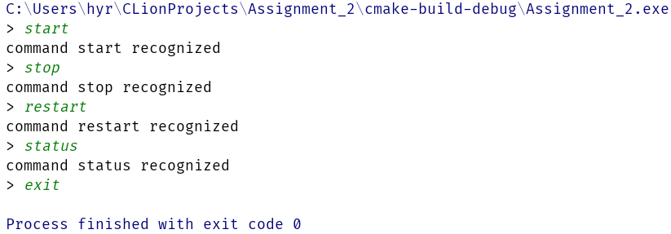

The output is correct.

**Test case #2:**

(The first input is with spaces in both sides)

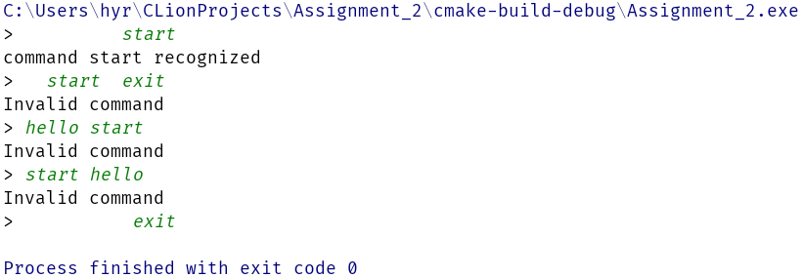

The output is correct.

**Test case #3:**

(Only press enter and only input white spaces)

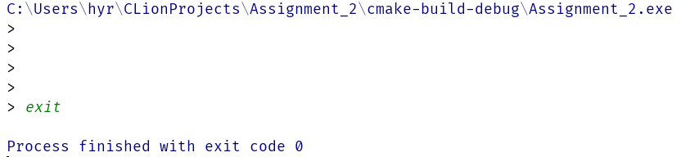

The output is correct.

**Test case #4:**

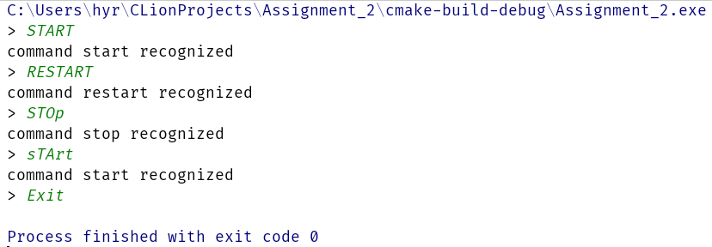

The output is correct.

**Part 4 - Difficulties & Solutions**

1. I want to get a string which I did not know its length in advance. So I used several methods to solve this problem. But none of them could deal with all the invalid solution safely. Finally, I asked my SA and he suggested me to search on the internet. I finally got a solution which can deal with all invalid inputs.
2. Before this assignment, I do not know how to use "#define" properly. By searching and tring, I finally get the right way to use it.